1. Tofield Municipal Library Membership
Does your child have a Tofield Municipal Library Card? | No. New or replacement card needed.  (previous card # ________________________)
Yes. Update membership information.
(Card # _______________________________)

2. Applicant Information (please print)

Student’s First Name Student’s Middle Name Student’s Last Name
____________________________________________________________________________________________________

Student’s Birthdate (MM/DD/YY) Student’s Gender Phone Number
____________________________________________________________________________________________________

Address/Box Number City/County Postal Code
____________________________________________________________________________________________________

Email address (Parent/Guardian)
____________________________________________________________________________________________________

3. Borrowing Limit
Borrowing Limit of Card: | Online Resources only* | 1 Book | 2 Books

*All cards will have access to online resources available through the Tofield Municipal Library website: https://www.tofieldlibrary.ca/eresources

4. Parent/Guardian Signature
I accept responsibility for the choice and use of library resources on this card and accept responsibility for the return of all materials borrowed and for fees on items that are overdue, lost or damaged and agree to abide by the policies of the Tofield Municipal Library.

____________________________________________________________________________________________________
Parent Name (print) Signature Date MM/DD/YY

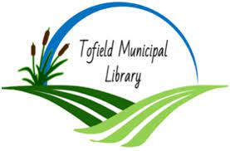
Please return the completed form to your child’s teacher.

Tofield Municipal Library Membership Customer Information is collected under the authority of the Alberta Libraries Act and the Freedom of Information and Protection of Privacy Act.

